**ASSIGNMENT 03**

192211135

G. Chandra Sekhar

INHERITANCE

Single inheritance:

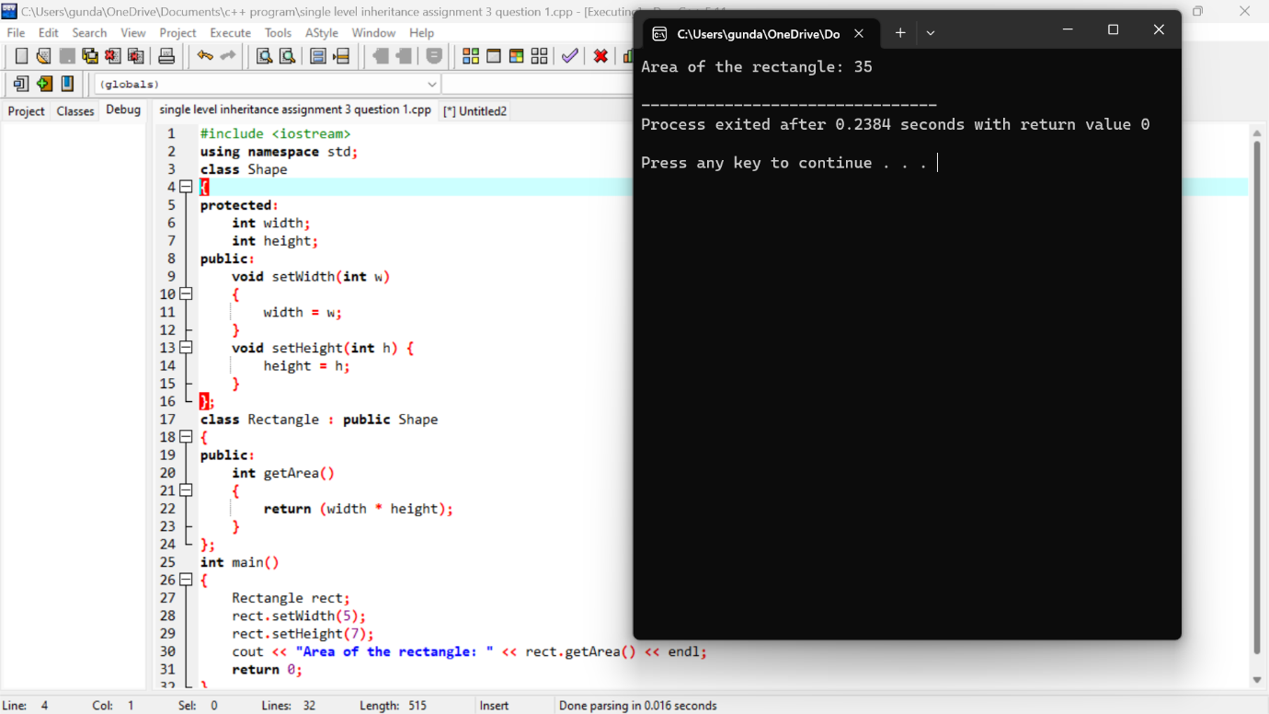

Multilevel inheritance:

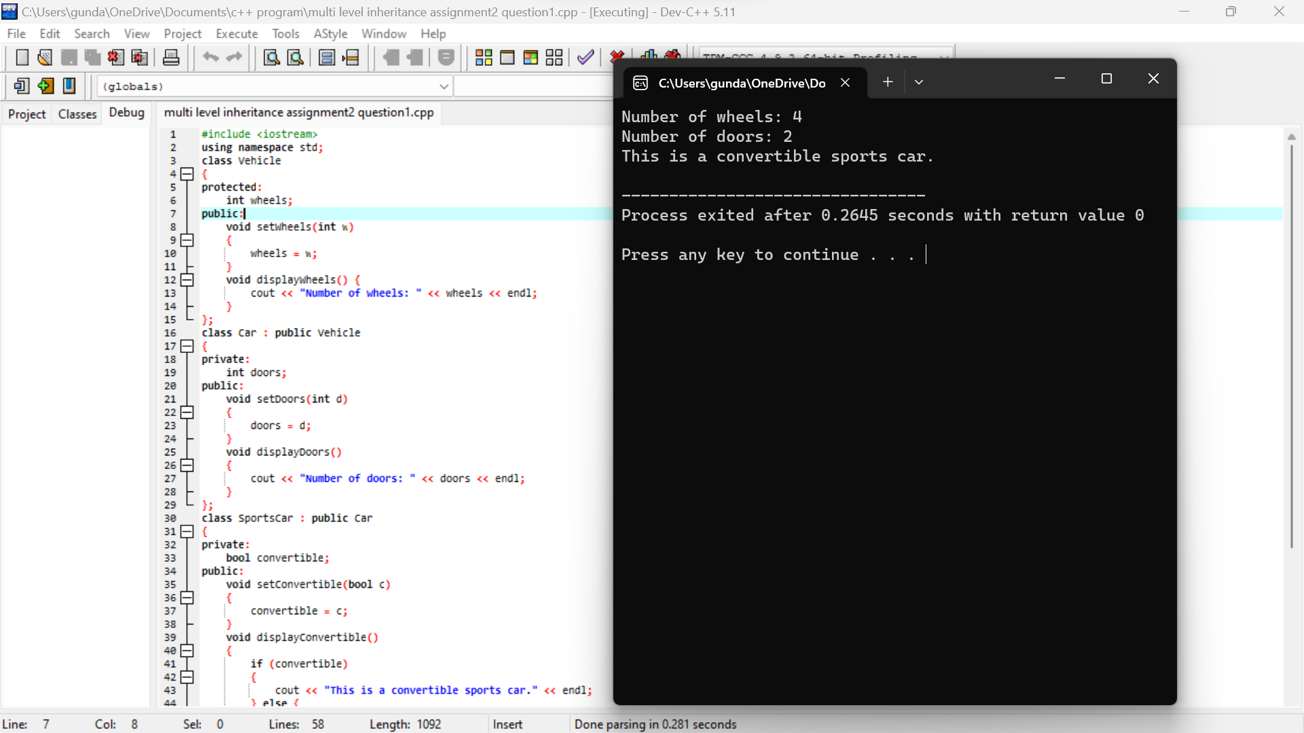

Multiple level inheritance:

